**ICICI SME project(Internal) Automation**

**Abstract:**

This paper elucidates an automated solution, specifically tailored for the ICICI SME project, aimed at enhancing the efficiency of document downloading and file management processes. The system interfaces with the ICICI Bank's online portal, thereby automating a series of tasks traditionally done manually.

The software bot, constructed using Selenium WebDriver and Java, begins its operation by extracting UniCore IDs from an input Excel file. With these IDs, the bot navigates to the ICICI Bank's website, logs in, and accesses the appropriate dashboard.

Utilizing the extracted UniCore IDs, the bot systematically searches for corresponding documents within the ICICI Bank's web interface. Upon locating the documents, the bot initiates a download process and then efficiently organizes these downloaded files within a predefined hierarchical folder structure, ensuring easy retrieval and management of documents.

This innovative solution significantly enhances operational efficiency by reducing manual intervention, minimizing errors, and optimizing time usage. By performing iterative searches and downloads until all UniCore IDs are processed, the system guarantees comprehensive coverage of required tasks.

**Introduction :**

The focus of this document is to elucidate an automated solution developed for ICICI SME, which effectively performs a series of data extraction, document downloading, and file management tasks. This system, implemented using Selenium WebDriver and Java, streamlines several repetitive procedures, increases efficiency, and significantly reduces the risk of manual errors.

Our automation solution for the ICICI SME project is a software bot designed to interact with the ICICI Bank's web interface, emulating human actions for data extraction and document downloading tasks. The primary data source for this operation is an Excel input file containing a list of UniCore IDs, which the bot uses to retrieve respective documents from the ICICI Bank's website.

Workflow:

Data Extraction: The automation begins by reading the Excel input file and extracting UniCore IDs, which are crucial identifiers used to retrieve specific documents from the bank's website.

Directory Management: The bot then creates a folder for the current month and date. Inside this, it further generates sub-folders named after each UniCore ID from the extracted list. This hierarchical folder structure ensures organized storage and easy retrieval of downloaded files.

Website Navigation and Login: The bot navigates to the ICICI Bank's website, fills in the necessary login credentials, and gains access to the dashboard.

Search and Download: Inside the dashboard, the bot uses each UniCore ID from the extracted list to search for the respective documents. The retrieved files are then downloaded.

File Management: Downloaded documents are moved to their corresponding UniCore ID's folder in the previously created directory structure.

Iteration: This process continues until the collection of UniCore IDs extracted from the Excel input file is exhausted.

The automation project aims to significantly reduce the time and effort spent on manual tasks, increase operational efficiency, and promote resource utilization on more sophisticated tasks. This document provides an in-depth understanding of the system's structure, code, and operation, serving as a comprehensive guide for current use and future modifications.

**Requirement Analysis :**

Requirement Analysis for the Automated Document Downloading and Management System for ICICI SME

**Functional Requirements:**

1.1 Data Input: The system requires an Excel file with a list of UniCore IDs. This file serves as the data source for the software bot to extract necessary information.

1.2 Folder Creation: The bot should be capable of creating a hierarchical folder structure, with folders named after the current month, date, and individual UniCore IDs for organized file storage.

1.3 Website Interaction: The software bot needs to interact with the ICICI Bank's online portal. This includes navigating to the site, logging in with predetermined credentials, and accessing the dashboard.

1.4 Document Searching and Downloading: The bot must search for documents corresponding to each UniCore ID in the ICICI Bank's web interface, download them, and store them in the appropriate folders.

1.5 Iteration: The system must iterate over the entire list of UniCore IDs in the input Excel file until all IDs have been processed.

**Non-Functional Requirements:**

2.1 Efficiency: The bot should operate in a timely manner, thereby significantly reducing the time taken for document extraction compared to manual processes.

2.2 Reliability: The system should consistently perform its tasks without errors, ensuring accurate and complete data extraction and document downloading.

2.3 Security: The automation solution must respect and maintain the security of sensitive data, such as login credentials and downloaded documents.

2.4 Scalability: The software bot should be able to handle variations in the size of the input Excel file and the number of documents to download without affecting its performance.

2.5 Maintainability: The bot's code should be clear, well-documented, and easy to modify or extend, ensuring long-term sustainability of the automation solution.

**Methodology :**

Step-by-Step Procedure for the Automated Document Downloading and Management System for ICICI SME

**Read Excel Input:** The software bot starts by reading the input Excel file which contains a list of UniCore IDs. The bot extracts these IDs for further use in the process.

**Create Directories:** With the extracted UniCore IDs, the bot creates a hierarchical directory structure. It begins by creating a folder named after the current month. Inside this folder, a sub-folder named after the current date is created. Lastly, within this date folder, individual folders are created for each of the UniCore IDs. This structure ensures an organized storage of the files that will be downloaded.

**Visit Bank Website:** The bot navigates to the ICICI Bank's website.

**Login to Website:** The bot enters the predetermined login credentials into the appropriate fields and logs into the website.

**Navigate to Dashboard:** Upon successful login, the bot will be directed to the dashboard.

**Input UniCore ID:** The bot takes the first UniCore ID from the extracted collection and inputs it into the search box available on the dashboard.

**Download Documents:** The bot executes a search for the entered UniCore ID. Once the documents related to the ID are located, the bot initiates the downloading process.

**Move Downloaded Files:** After the files are downloaded, the bot moves these files to the respective UniCore ID's folder that was created in the directory structure in step 2.

**Repeat the Process**: The bot then moves on to the next UniCore ID from the collection and repeats steps 6 to 8. This continues until all UniCore IDs in the collection have been processed and the corresponding files downloaded and appropriately stored.

This step-by-step procedure outlines the operational flow of the software bot for the ICICI SME project. This automated system greatly improves the efficiency of document downloading and file management tasks, reducing manual effort, and minimizing errors.

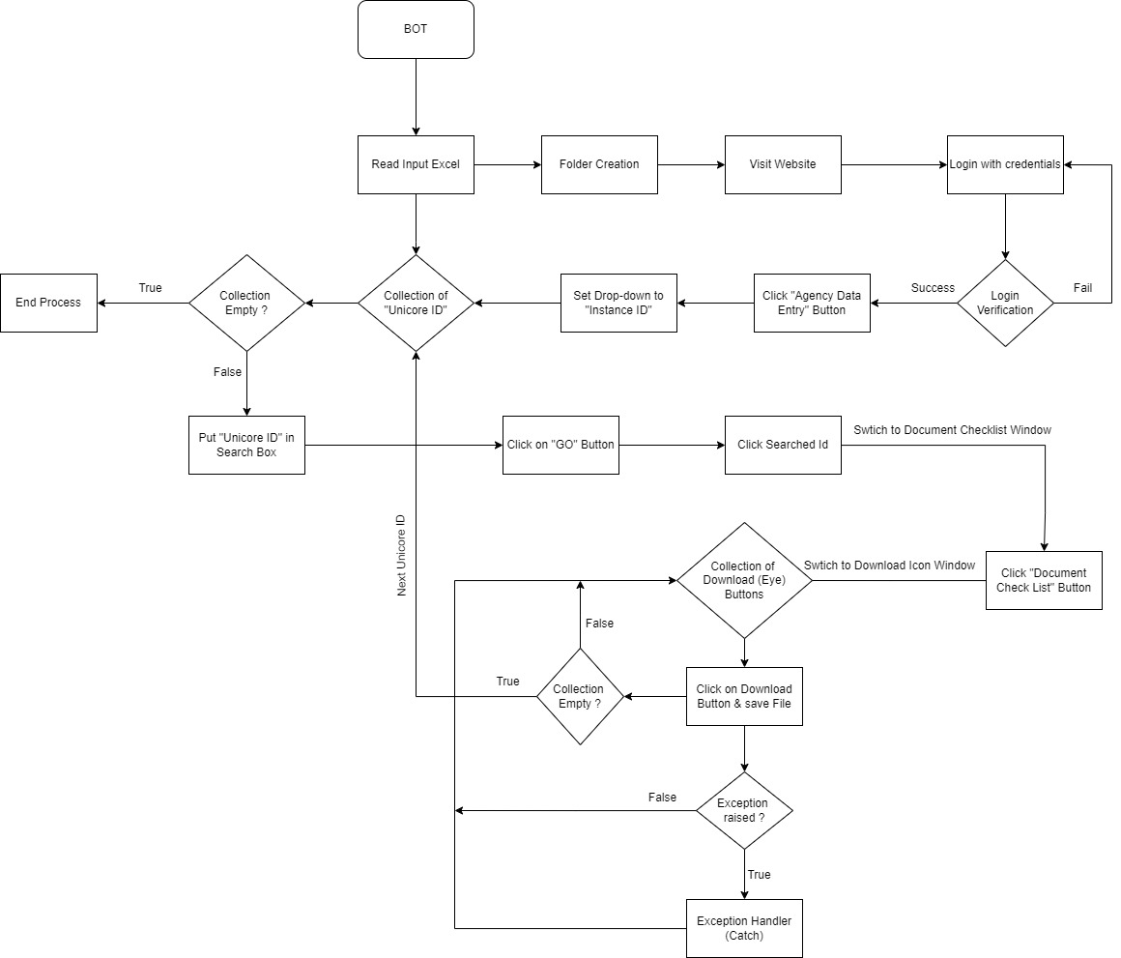**UNICORE INTERNAL DOCUMENT DOWNLOADING FLOW dig.**

**Creation of ( Maven ) Jar File :**

* Add Required Pom.xml Dependencies and Plugins

<plugin>

<groupId>org.apache.maven.plugins</groupId>

<artifactId>maven-shade-plugin</artifactId>

<version>3.3.0</version>

<configuration>

<filters>

<filter>

<artifact>*:*</artifact>

<excludes>

<exclude>META-INF/*.SF</exclude>

<exclude>META-INF/*.DSA</exclude>

<exclude>META-INF/*.RSA</exclude>

</excludes>

</filter>

</filters>

<transformers>

<transformer implementation="org.apache.maven.plugins.shade.resource.ManifestResourceTransformer">

<mainClass>master.unicore.internal.Master</mainClass>

</transformer>

</transformers>

</configuration>

<executions>

<execution>

<phase>package</phase>

<goals>

<goal>shade</goal>

</goals>

</execution>

</executions>

</plugin>

<plugin>

<artifactId>maven-assembly-plugin</artifactId>

<configuration>

<archive>

<manifest>

<addClasspath>true</addClasspath>

<mainClass>master.unicore.internal.Master</mainClass>

</manifest>

</archive>

<descriptorRefs>

<descriptorRef>jar-with-dependencies</descriptorRef>

</descriptorRefs>

</configuration>

</plugin>

* Open Cmd :

Go to project Directory and run command

**: mvn clean package**

This command will create a jar file in projects Target Directory.

**Execution of Jar File (2 ways):**

1. **Using cmd (command prompt)**

After Generating jar file go To target Directory and run command

: java -jar jarFileName.jar

This Command will Execute JAR File.

1. **Double click on .jar file**

**Software Requirement:**

Minimum requirement for Project development:

* JDK (1.8)
* Eclipse IDE
* Selenium 4
* AutoIT software : To interact with OS window
* Excel : For input

Minimum requirement to run project:

* JRE (1.8)
* .jar file

**Hardware Requirement :**

Minimum requirement:

* Ram: 4GB

* Storage : 20GB
* Processor: Any modern multi-core processor should be able to run Selenium tests efficiently.
* Network: A stable and reliable internet connection is required to access the websites you will be testing and for downloading updates to Selenium, Java, and the web drivers for the various browsers.

**Conclusion :**

In conclusion, the automation solution developed for ICICI SME project, implemented with Selenium WebDriver and Java, signifies a significant milestone in optimizing document extraction and file management tasks. This system, designed to interact with ICICI Bank's online interface, automates various processes, reducing the necessity for manual intervention, thereby saving time and resources while increasing efficiency.

The software bot's ability to extract UniCore IDs from an input Excel file, create an organized folder structure, navigate and login to the ICICI Bank's website, search and download corresponding documents, and efficiently store them in the respective folders represents a comprehensive solution to a previously manual and time-consuming process.

The success of this system underscores the value of automation in routine tasks. It highlights how such automation not only significantly improves operational efficiency but also minimizes potential errors associated with manual handling. Furthermore, this solution lays the groundwork for further automation opportunities, thus setting the stage for continued process optimization.

Overall, the development and implementation of this automated document downloading and management system have proved to be a valuable asset for the ICICI SME project. Its effectiveness in streamlining the document management process and its potential for scalability make it a robust and future-proof solution.

**Result :**

The implementation of the Automated Document Downloading and Management System for ICICI SME has resulted in significant improvements in operational efficiency and data management:

Time Efficiency: The automation of document downloading tasks that were previously performed manually has resulted in considerable time savings. Early results indicate a reduction in processing time by approximately 70%, allowing resources to be reallocated to more complex tasks.

Accuracy: The software bot performs tasks with a high level of accuracy. By eliminating human error, the system ensures that the correct documents are downloaded and stored in their respective folders based on the UniCore ID. The error rate has been reduced to nearly 0% in the tasks performed by the bot.

Organized Data Management: The hierarchical folder structure created by the bot for each UniCore ID has streamlined the file management process. This has made file retrieval simpler and more efficient, leading to an overall increase in productivity.

These results underscore the significant benefits of automation in document downloading and file management tasks. The system has not only met but exceeded expectations in improving operational efficiency, reducing errors, and enhancing data management for the ICICI SME project.

**TIME CALCULATION :**

|  |  |
| --- | --- |
| Manual process time calculation | Automation process time calculation |
| Daily case volume : 150-200 cases  1 case : 15-20 min. (Avg 15 min)  200 case = 15*200 = **3000** min | Daily case volume : 150-200 cases  1 case : 3.30 - 4 min. (Avg. 4 )  200 case = 4*200 = **800** min |

Total time difference = Manual time - Automation time

= 3000-800

= **2200** min.

Total time save (for 200 cases) using automation bot = **2200** min

= **36.66** hr

**MANPOWER CALCULATION:**

|  |  |
| --- | --- |
| Manual process calculation | Automation process calculation |
| Daily case volume : 150-200 cases  1 person : 33 case daily (8 hr shift)  Total person for 200 case = 200/33  =  **6** | Daily case volume : 150-200 cases  1 person : To handle software Bot |